Experiment: 7 Analog Beamforming Analysis Using MATLAB

Aim
To analyze the performance of analog beamforming by studying beamforming gain, beam width, main lobe direction using MATLAB.
Objective 1:
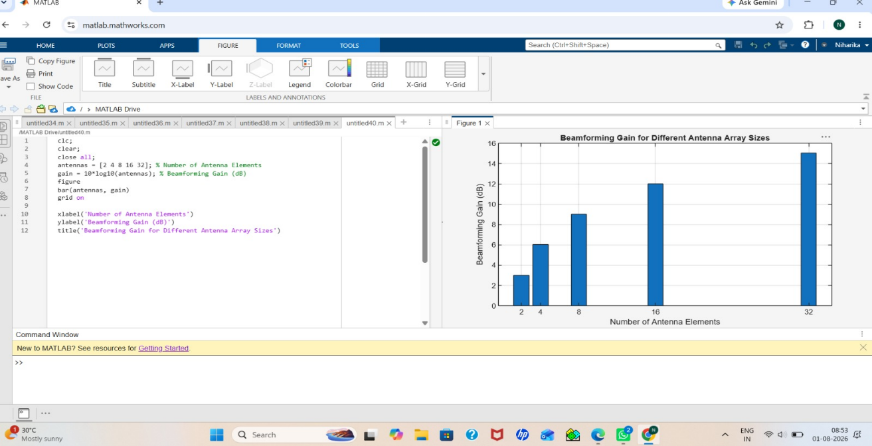

Objective 2:
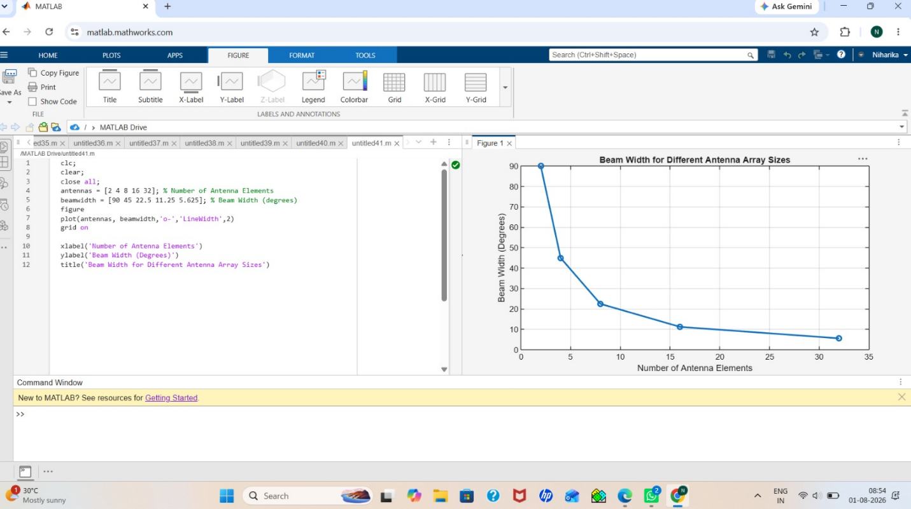
Objective 3:
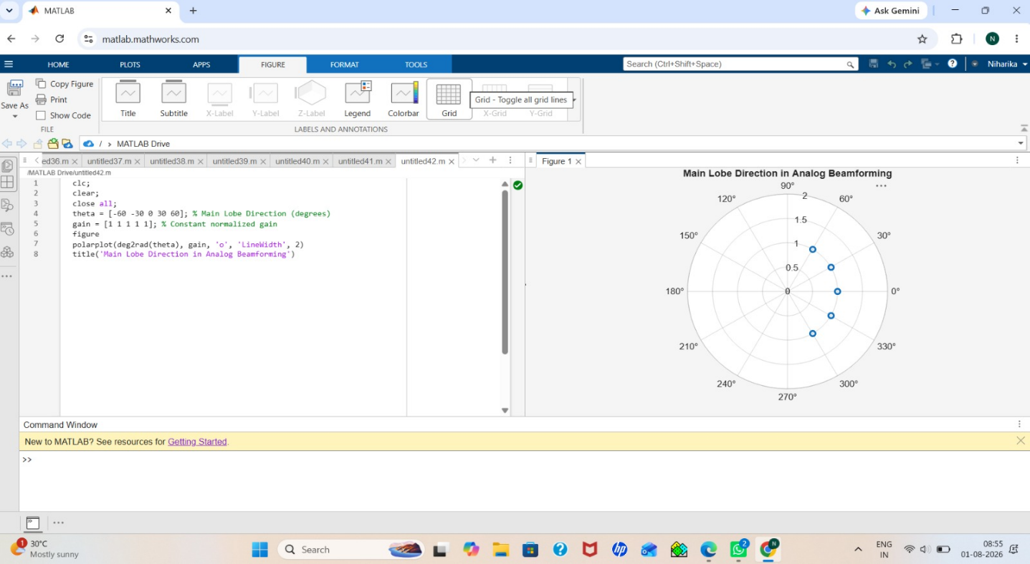
Result:
The MATLAB analysis successfully demonstrated the characteristics of analog beamforming. The results showed that increasing the number of antenna elements improves beamforming gain and reduces beam width, while phase adjustment enables the main lobe to be steered toward different directions.

